**Project Description**

Description: This program determines if a student or faculty member is in accordance with the Fayetteville Technical Community College Covid-19 Temperature Policy. The user will input the student or faculty members temperature and follow the instructions on the screen. Positive Covid cases will be recorded and saved to a separate document in the PositiveTrackerDocs folder. The daily tracker total will be saved in a separate document in the CovidDocs folder.

**Project Tests:**

**1. Program tests begin on page 59 and end on page 65.**

**2. The Program tests page is also bookmarked for quick access.**

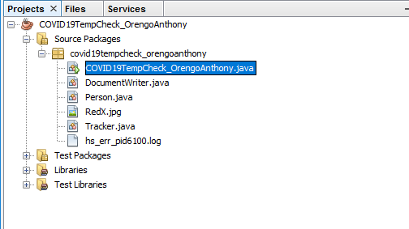**Project Files**

**Program Code Location:**

**\*COVID19TempCheck_OrengoAnthony**

**Lines 1-35**

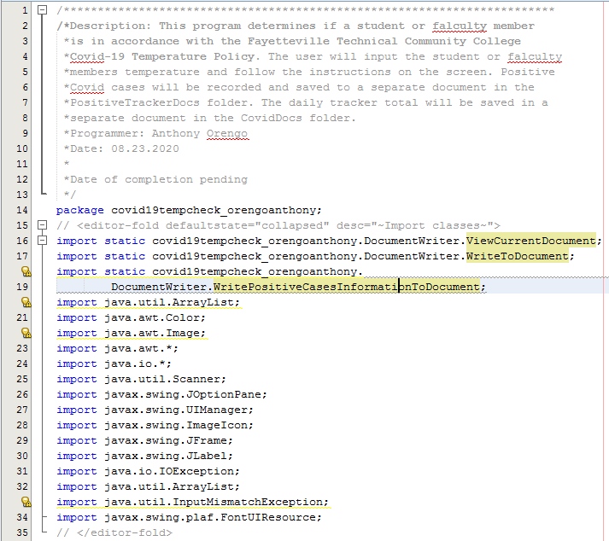

**Lines 35-70**

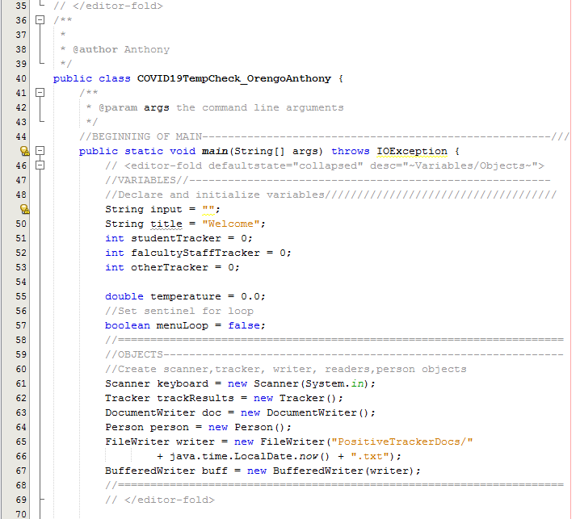

**Lines 70-105**

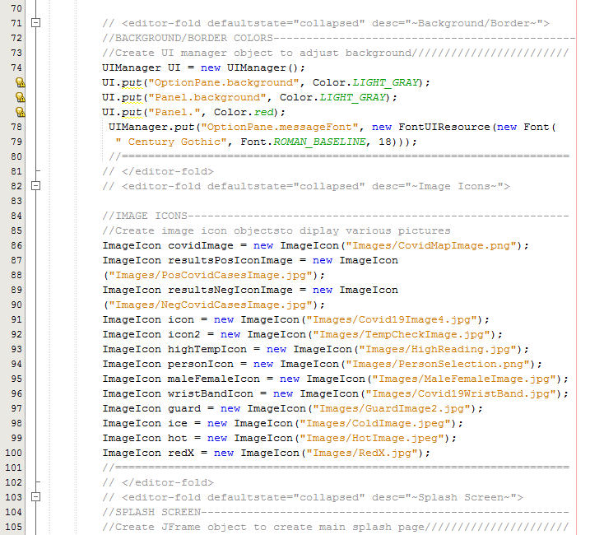

**Lines 105-145**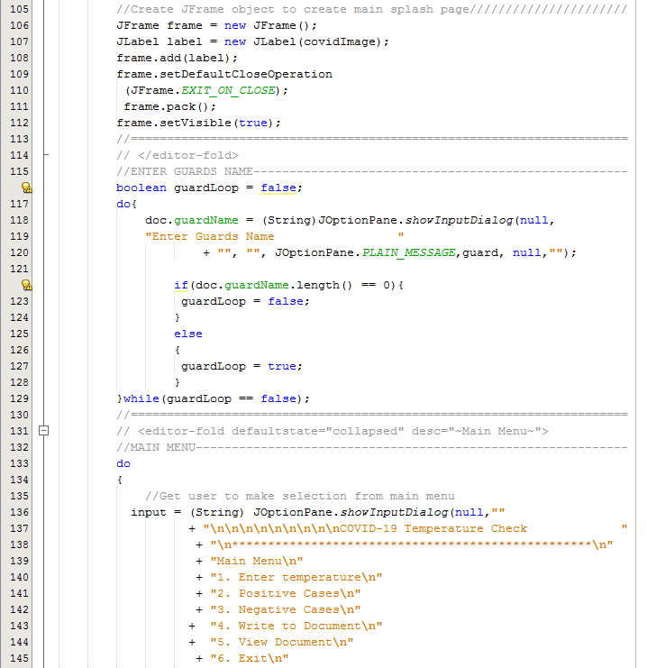

**Lines 145-185**

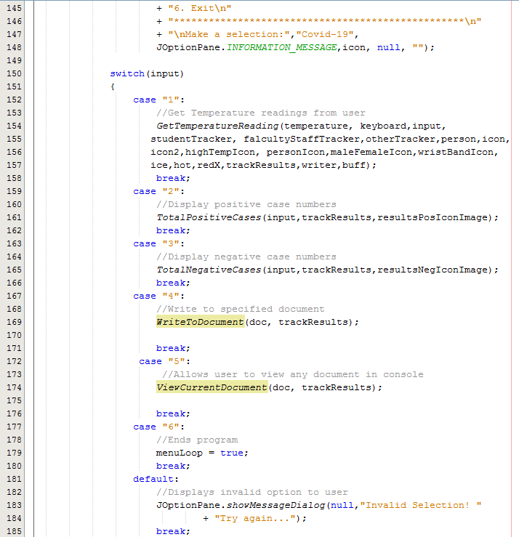

**Lines 185—225**

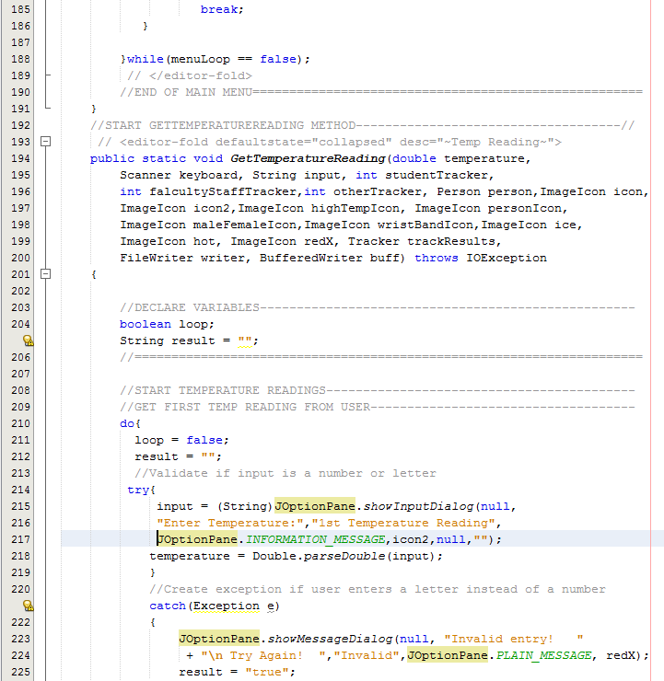

**Lines 225-265**

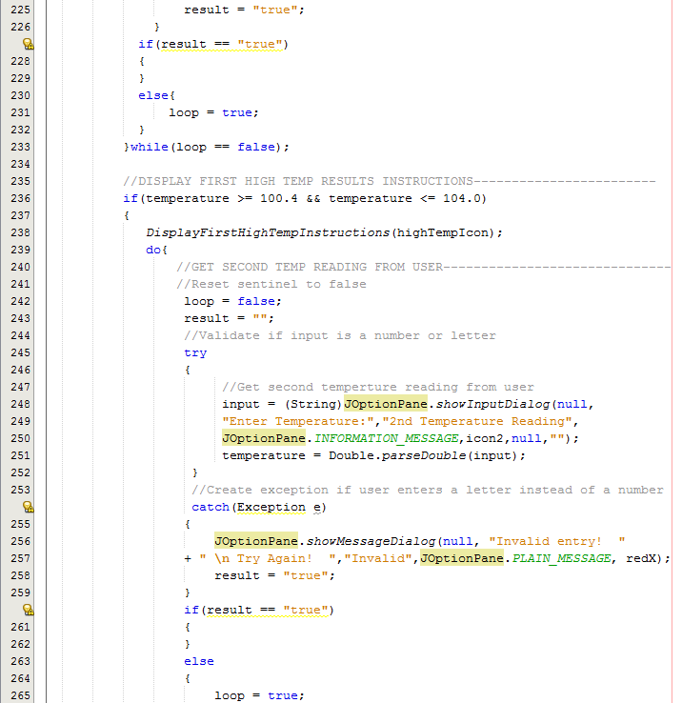

**Lines 265-308**

**Lines 308-350**

**Lines 350-390**

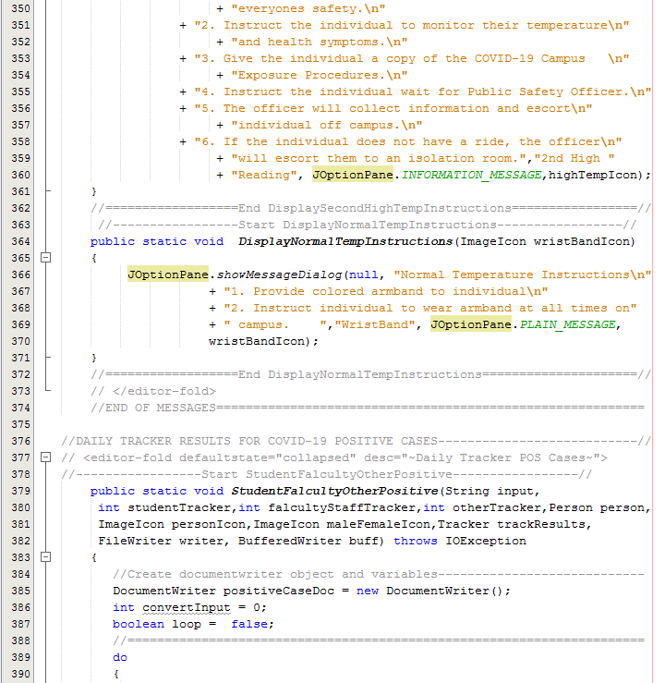

**Lines 390-430**

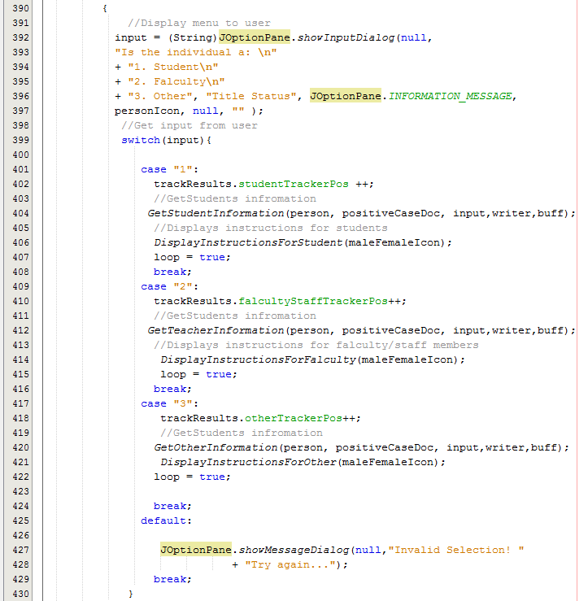

**Lines 430-473**

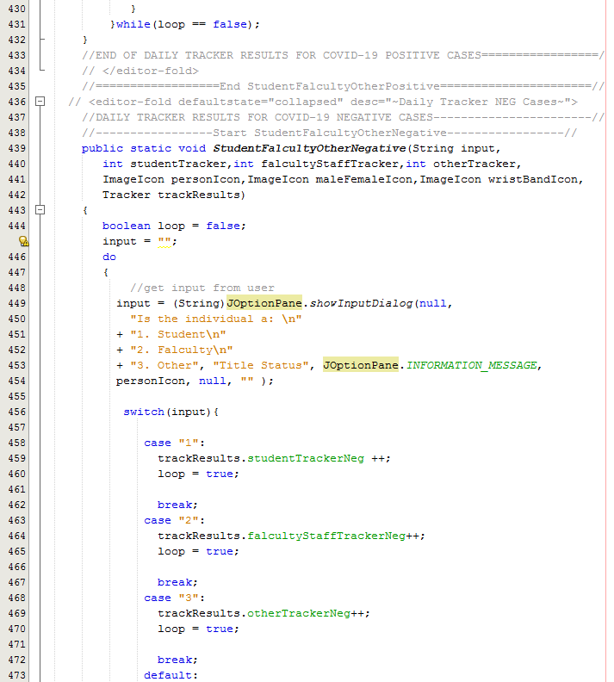

**Lines 473-513**

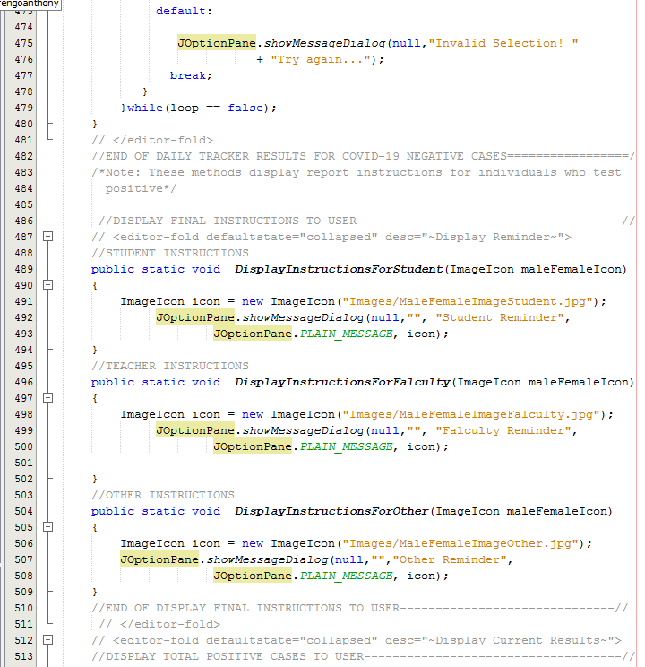

**Lines 513-553**

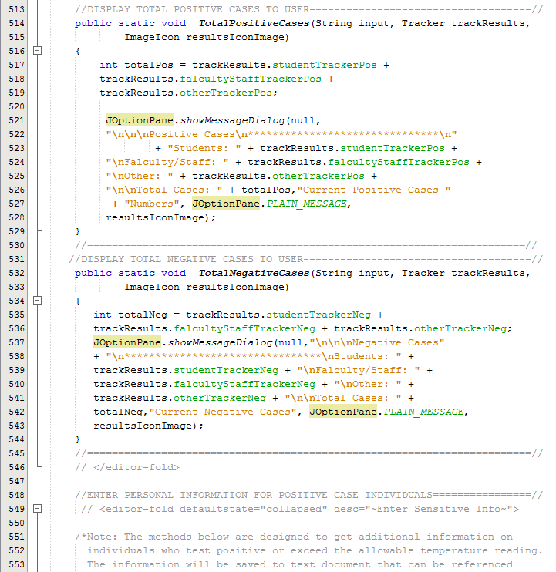

**Lines 553-593**

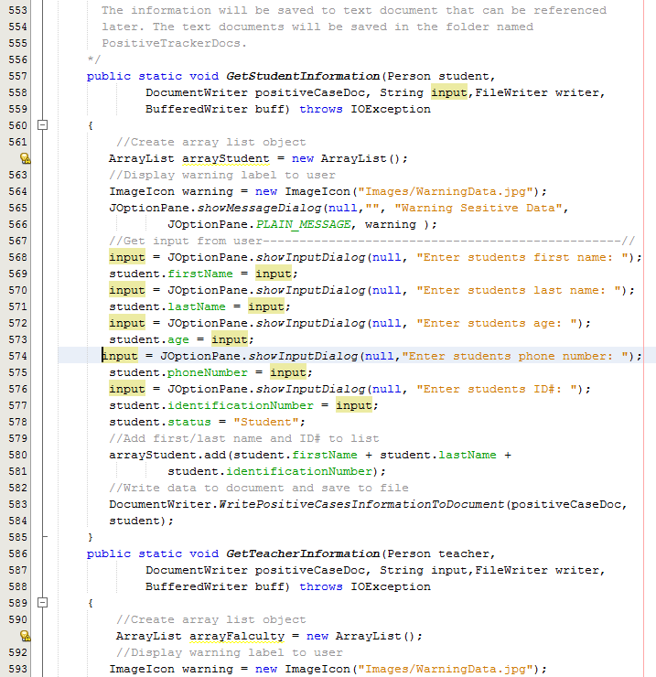

**Lines 593-633**

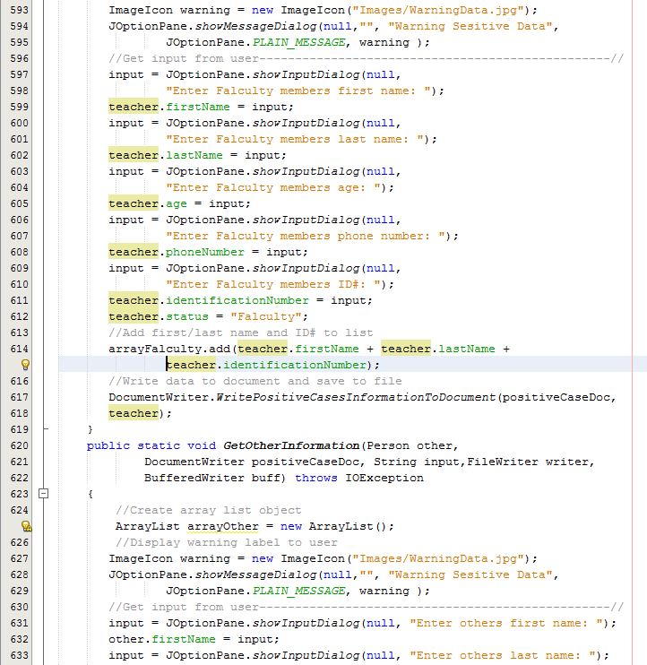

**Lines 633-658**

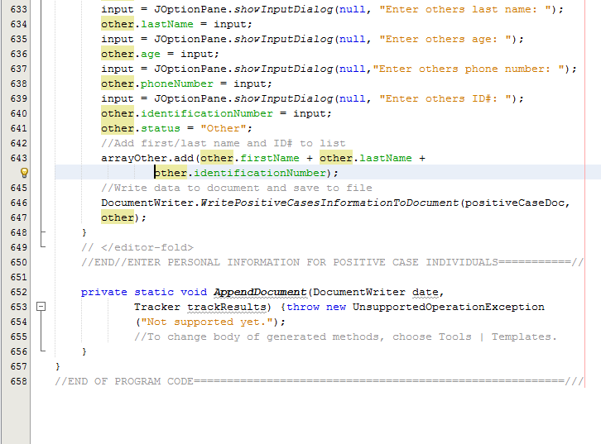

***END OF **COVID19TempCheck_OrengoAnthony**

**DocumentWriter.java**

**Lines 1-28**

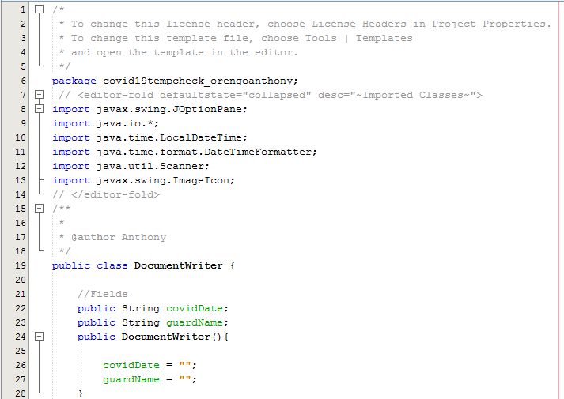

**Lines 28-68**

**Lines 68-99**

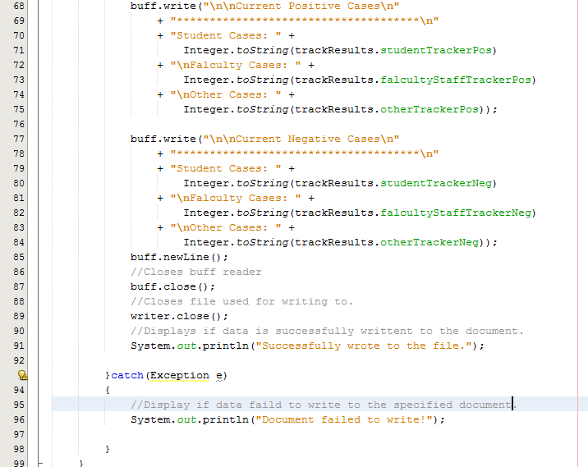

**Lines 99-140**

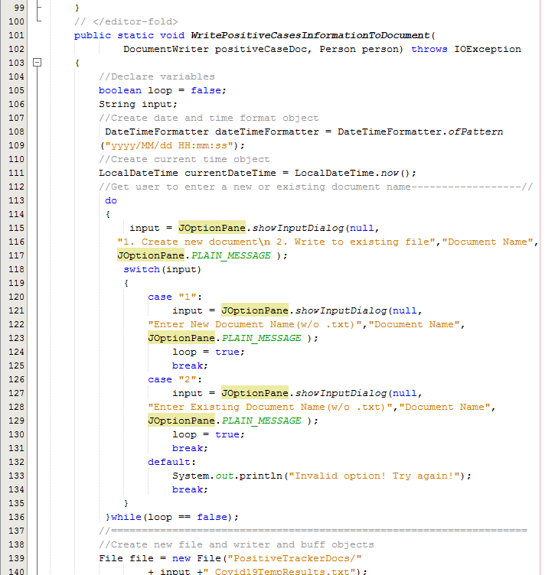

**Lines 140-180**

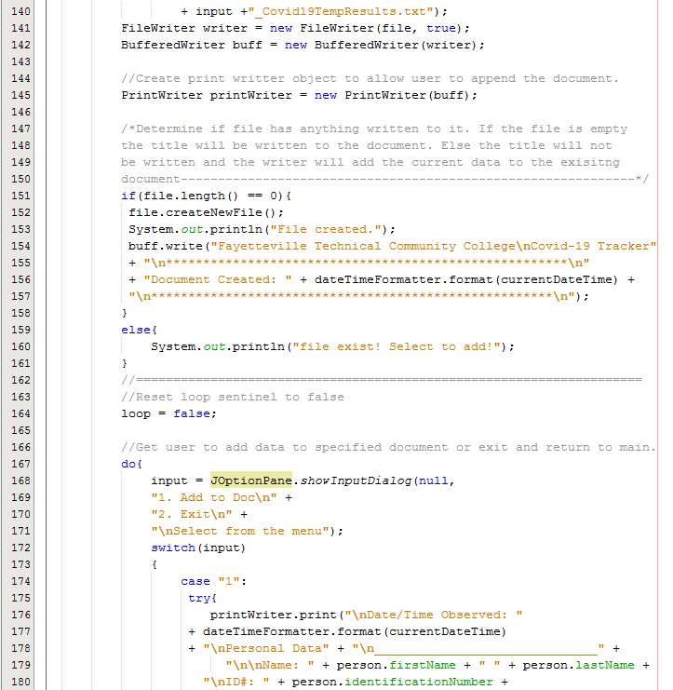

**Lines 180-207**

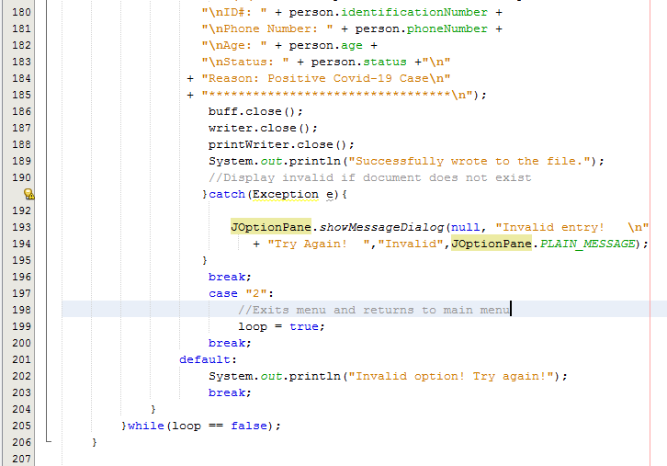

**Lines 207-247**

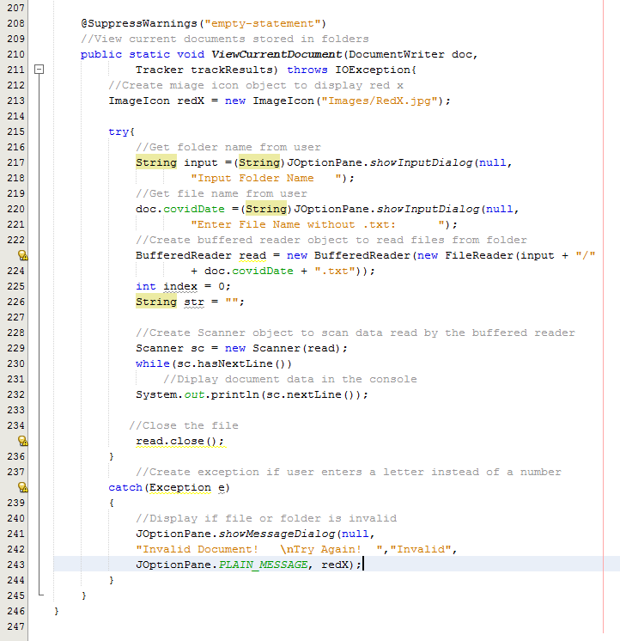

**End of DocumentWriter.java**

**Person.java class**

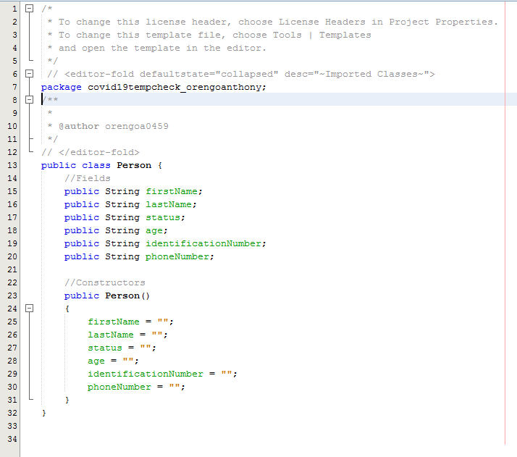

**End of Person.java class**

**Tracker.java Class**

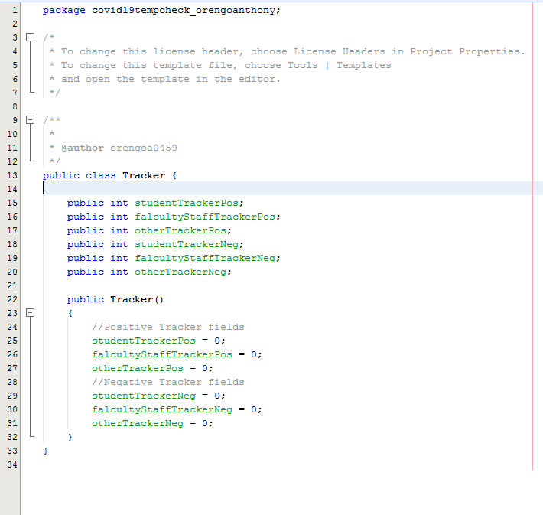

**End of Tracker.java Class----------------------------------------------------------------------------------------**

**Program Output:**

**Main Page:**

**Enter Temperature Guards Name**

**Main Menu Page:**

**Enter First Temperature**

**1st High Temperature reading**

**Enter Second Temperature**

**2nd High Temperature reading**

**Enter Status Page:**

**Sensitive Data Warning Page:**

**Enter Name:**

**Enter Last Name**

**Enter Age**

**Enter Phone Number**

**Enter ID#**

**Create/Use Existing Document**

**Enter Document Name:**

**Add To Document Page**

**Document Created**

**Full Document**

**Display Instructions to Student**

**Teacher Temp Reading**

**Steps skipped to avoid redundancy: Temperature Readings/Instructions**

**Enter Name:**

**Enter Last Name**

**Enter Age**

**Enter Phone Number**

**Enter ID#**

**Enter to Existing Document:**

**Add to Document**

**Document Appended:**

**Faculty Instructions**

**Other Temp Reading**

**Steps skipped to avoid redundancy: Temperature Readings/Instructions**

**Enter Name:**

**Enter Last Name**

**Enter Age**

**Enter Phone Number**

**Enter ID#**

**Enter to Existing Document:**

**Add to Document**

**Document Appended:**

**Faculty Instructions**

**End of Input--------------------------------------------------------------------------------------------------//**

**Display Positive Cases**

**Negative Case Input:**

**1st Temperature Reading**

**Display Instructions to User**

**Individuals Status:**

**1st Temperature Reading High**

**2nd Temperature Reading Normal**

**Display Instructions**

**Display Negative Cases**

**Write to Daily Tracker to Document:**

**1. Enter 4 on main menu**

**Create File:**

**Created File:**

**Display Document**

**View Documents**

**All Files will be viewed through the Netbeans Console**

**Input Folder Name**

**Input File Name**

**Console View**

**CovidDailyTrackerDocs\19OCT2020**

**Viewed File**

**PositiveTrackerDocs\19OCT2020_Covid19TempResults**

**Invalid Input Displays**

**Main Menu Invalid Selection**

**Enter Invalid Temperature**

**Invalid Temperature Input**

**Program Test**

Below are the numbers that will be used to test the maximum safe temp and the minimum unsafe temp.

**When you run your program, use the temperatures below as your inputs:**

1. **100.3**
2. **100.4**

**TEST ONE RESULTS:**

**USING: 100.3**

**Input 100.3**

**Results using 100.3**

**Enter Status:**

**TEST TWO RESULTS:**

**USING: 100.4**

**\*\*End of Test----------------------------------------------------**